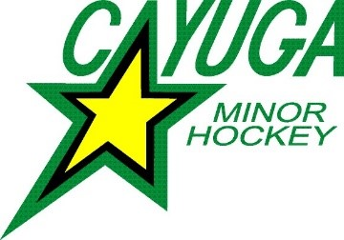

|  |
| --- |
| **For Office Use Only** |
| Team ID: |
| # of Players: |
| # of Goalies: |

**Cayuga MHA Team Roster Request Form**

Division, Team #:

D.O.B. of Coaching Staff is Required!

Sponsor, Colour:

Head Coach: D.O.B.

Trainer: D.O.B.

Please check one:

Asst. Coach Trainer D.O.B.

Asst. Coach Trainer D.O.B.

Asst. Coach Trainer Manager  D.O.B.

After the coach and trainer positions are filled, additional team officials may be designated up to a maximum of five (5). If a team wishes to add additional personnel, they will be designated as either assistant coach or assistant trainer or manager. The team may only add one Manager to their roster having only Respect in Sport (RiS)-Activity Leader or Speak Out as a qualification.

|  |  |  |  |  |
| --- | --- | --- | --- | --- |
| Goalie: | | | Jersey # |  |
| Goalie: | | | Jersey # |  |
| List in alphabetical order by surname: | | |  |  |
| 1. | Player: |  | Jersey # |  |
| 2. | Player: |  | Jersey # |  |
| 3. | Player: |  | Jersey # |  |
| 4. | Player: |  | Jersey # |  |
| 5. | Player: |  | Jersey # |  |
| 6. | Player: |  | Jersey # |  |
| 7. | Player: |  | Jersey # |  |
| 8. | Player: |  | Jersey # |  |
| 9. | Player: |  | Jersey # |  |
| 10. | Player: |  | Jersey # |  |
| 11. | Player: |  | Jersey # |  |
| 12. | Player: |  | Jersey # |  |
| 13. | Player: |  | Jersey # |  |
| 14. | Player: |  | Jersey # |  |
| 15. | Player: |  | Jersey # |  |
| 16. | Player: |  | Jersey # |  |
| 17. | Player: |  | Jersey # |  |

**Please submit your roster to**

**Katherine Hedley Cayuga Minor Hockey Registrar**

[**katherinehedley68@gmail.com**](mailto:katherinehedley68@gmail.com)